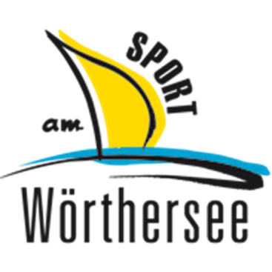
 | chairman: | Werner Uran | Mob.: +43 664 3839502
 | team leader triathlon: | Rudi Sima | Mob.: +43 676 6909740

press release/announcement

3rd CROSS KIDS CUP

The club “Sport am Wörthersee” is hosting the Cross Kids Cup for the third time, an event where kids can prove their sportiness in three disciplines – Bike, Swim and Run. The goal of the event is to promote the fascination of triathlon among children and young people, therefore the club “Sport am Wörthersee”, with Werner Uran as chairman und Rudi Sima as team leader of the section triathlon, has created a series of events.

In the last years, these events have become a great happening and have already attracted many young sportspeople for triathlon.

Kids and young people between 6 and 23 have the possibility to get to know the three disciplines of triathlon.

The Cross Kids Cup contains three disciplines and is carried out in six groups:

SWIM / BIKE / RUN

For a successful participation at the Cross Kids Cup you will have to follow special rules to finish positively.

Swim
At this discipline, no aids like water wings, flippers, snorkels etc. are allowed

Bike
The only bikes allowed are mountain bikes. The race area will be within a restricted area. At this discipline, it is obliged to exit the changing zone before getting on the bike. Biking with naked upper body is restricted. It is essential to wear a helmet during the whole bike race.

Run
It is mandatory to wear a t-shirt or anything that covers the upper body. It is restricted to run without shoes. During the race, it is not allowed that a third person accompanies or coaches the participant.

The race venues will be Spittal, Völkermarkt, Feistritz/Rosental and Velden.

21th Mai 2017 Spittal/Drautalperle
18th Juni 2017 Völkermarkt, Erlebnisschwimmbad
24th Juni 2017 Feistritz/Rosental , WaHaHa
09th Juli 2017 Velden, Cap Wörth – final event

The organizers of the events are optimally prepared for this year’s Cross Kids Cup and are happy to welcome many participants.

You will find further information on our website: www.s-a-w.at.

